HEDSA SECRETARIAT
Email: info@hedsa.org.za
Twitter: @HEDSA_ORG

Accepted as a community of practice by Universities South Africa.
Registered as an NPO no. 078-484
__________________________________________________________________________________________
Dear HEDSA Family and Friends
Attached with this newsletter are a few important documents:
- The latest version of the symposium Programme.
- The form to be used should you want to nominate someone for one of the positions on the HEDSA Executive committee which will be elected at the Biennial General Meeting and who will serve for the next two-year period. Hopefully you will have taken to heart my exhortations earlier in the year to think very carefully when you nominate a colleague about whether they have the requisite skills, and importantly, the time.
- Proposed amendments to the 2012 HEDSA constitution. Please have a look at these so you can vote on these during the Biennial General Meeting.

Symposium
Probably to no one’s great surprise I begin this newsletter with yet another plug for our upcoming symposium. It is heartening to see that interest is growing and registrations are flowing in more steadily than before. The concern I have to say is that the result of an almost certainly extended academic timetable at most institutions will compromise symposium attendance by University students and personnel who would be affected by extended work commitments. At UCT we have been informed that our exams will start on 7 November and end on 25 November; and as was the case in 2015 graduation ceremonies will have to be postponed to June next year.
So to get back briefly to the symposium: We will still be making fine adjustments to the program as issues are raised which we feel need an airing at a national symposium like this. There is still time to register. I notice some potential delegates were under the impression that it was too late to register, but in fact the only deadline that we more or less stuck to was the early bird discount, so please look again at the program and campaign for funds to attend. The closing date for registrations is the 10 November 2016 and payment for symposium fees is the 20 November 2016. All correspondences regarding the symposium and registration payments can be sent to info@hedsa.org.za. Kindly CC dianeb@sun.ac.za and reinette.popplestone@uct.ac.za in your correspondence. For symposium and all other HEDSA updates follow us on twitter @HEDSA_ORG.

Mapability
All HEI’s would by now have received a request to respond to the Mapability Survey. This is a HEDSA project which will in time enable prospective students with disabilities to ascertain exactly the level of accessibility of various institutions, and to make their study choice accordingly. We urge you to complete the survey. The symposium will present an opportunity to learn more about this. If you did not receive a survey then please email HEDSA to request one.
There will be a prize draw for one lucky institution that has completed the Mapability Survey. Sensory Solutions will be giving away the Sensory PBR Book Reader & Recorder. Featuring their very own Portable Book Reader and Voice Recorder, this convenient nifty device allows students to playback digital talking books or textbooks, and also to record lectures.

Improving Teaching, Learning and Work Opportunities for Deaf Students.
On 24 and 25 June 2016 a meeting took place on the Potchefstroom campus of North West University. Its purpose was to bring various stakeholders together to strategise about improving teaching and learning at all levels of education and work opportunities for Deaf learners and students. The strategic meeting was aimed at Basic and Higher Education, NPOs and DPOs, Our public relations member of Exco, Maria Ramaahlo represented HEDSA at this important event. Maria reports as follows:
“I was asked to present on the work of HEDSA as well as UP. Rather than only focusing on our best practices we also discussed areas of improvement regarding support for Deaf learners”.
The following objectives were achieved or set:
- Establishing a network by sharing best practices and resources.
- Establishing a pathway towards achieving SASL as the 12th official language of SA.
- Deciding what should be the focus in the immediate future: especially developing strategies (and implementing them) re: the training of skilled teachers in SASL in order to open educational possibilities for the Deaf community. It was proposed that to enable us to have a long term impact, the resources of the Open Distance learning programme of the NWU and the National Institute for the Deaf should be utilised.
- A task team was appointed to develop a plan to take us further (under the leadership of Dr Pieter Smal). For the task team, Martie Marinda and Susan Lombard from UFS will represent Higher Education.

Teaching and Learning Research Project
Readers of this newsletter with good memories may recall the conference in March last year which was the first phase in a Teaching and Learning Framework Research Project spearheaded by UNISA. 11 institutions participated in the information gathering phase which followed the conference and the release of the conference report.
On 28 September 2016 the steering committee and other interested parties attended a presentation of the findings of this research. The final report will be released in the near future. In one sense one might say the report didn’t tell us anything we didn’t know – that teaching and support staff had inadequate knowledge of how to accommodate disabled students in their class, and much more. The next phase of this project will consist in developing the training material to be used to address the very gaps in knowledge and skills uncovered by the research – to provide tools with which to implement in a systematic and meaningful way the recommendations that came out of this research.

HEDSA FAMILY NEWS

Congratulations are in order
HEDSA’s previous chair, Ms Marcia Lyner-Cleophas has completed all requirements to be awarded her PhD and will be the wearer of the Red Gown in December. We look forward to adding her research to the body of research regarding disability in the HE sector to this growing body of knowledge.
Congratulations are also due to Kaylyn Alexander whom many of you have gotten to know over the last year and a bit in her role as HEDSA administrator/fund raising co-ordinator. Kaylyn surprised us all earlier this year with her news that she was going to have a baby boy some time in November. Kaylyn’s baby was due on the day of the symposium! But recently we had an even bigger surprise when young Mason Alexander was born more than two months premature on Saturday morning 17 September. Mason is doing well although he is still in hospital. May this new family be richly blessed and held safely in the hand of the Almighty from this to their very last day.
Dr Nina du Toit, will be embarking on an exciting new career venture in the field of disability studies. She has been invited by the University of Ghent to collaborate on a research project on persons with disabilities. She will be based in Belgium for the next 10 months. We congratulate her on this collaboration and wish her all the best.

Some farewells will soon be in order
I may have mentioned that I will be retiring as Head of the Disability Unit at UCT on 31 December. But I will be around for at least next year as I assume my role as immediate past chair on the Executive for one year. UCT will also be bidding farewell to another HEDSA stalwart. Nafisa Mayat will also be finishing at UCT on December 31. She is planning to move back to KZN where she will be heading up a NPO in which her family is extensively involved. But fortunately we won’t be losing Nafisa’s considerable skills either. She will remain on the Board of NSFAS to which she was appointed in the course of last year, having been nominated by HEDSA. Nafisa has done sterling work since being on the Board but even before that she worked extremely hard on the NSFAS Disability Bursary Policy. (In fact, maybe we should start referring to the Mayat Policy rather like other important documents are referred to, e.g. “the Soudien report”! The appointment on the board is for a four-year term, so I have no doubt that we’ll be seeing Nafisa around.
And so on to news from our member institutions. I was particularly impressed with UP’s initiative to create a rest area for guide dogs, but read on. This is certainly a first in the country to my knowledge.
University of Pretoria Athlete with a Disability Graduates with MA Degree
Perseverance overcomes failure and turns the extraordinary achievement into great success.' These words certainly apply to Carley Lomax, a student with a visual disability at the University of Pretoria (UP), who graduated with an MA degree in Recreation and Sport Management at the University's Autumn Graduation Ceremony on 6 April 2016.
Carley joined TuksAthletics in 2007 to compete in the 100 m, 200 m, and long-jump events while pursuing her academic career. During her time at UP she represented the institution at several University Sports South Africa (USSA) championships and in 2013 she was selected as a finalist for the Gauteng Sports Awards in the category Female Athlete with a Disability. In addition to the above, she represented South Africa at the International Blind Sport Association (IBSA)'s athletics world championships in 2007 and was selected to participate in the 2015 All Africa Games. After the graduation ceremony, an elated Carley said: 'Juggling academics and sport, and dealing with the challenges presented by both was no easy feat. One never realises the value of what you are doing until you are up on that podium and people are cheering and applauding.'
Carley's passion for sports and fitness has inspired her to continue her studies and she is currently studying towards a Postgraduate Certificate in Education (PGCE) at UP. She hopes to obtain a teaching position at a school so that she can combine her knowledge of sports sciences and fitness to assist with the development and improvement of sports in local schools. Her advice to aspiring athletes and students is to never give up on their dreams. She hopes to inspire many young people to persevere in pursuing their dreams, just as she had been inspired by another South African athlete, Geraldine Pillay, known mainly for her achievements in the 100- and 200-metre sprints.
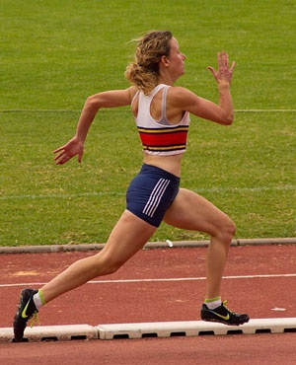
New Rest Area for Guide Dogs at UP
The Department of Facilities Management at the University of Pretoria (UP) has built a dedicated rest area for guide dogs in the garden outside the Disability Unit's offices on the Hatfield Campus. This is just the latest example of the University's comprehensive accommodation of persons living with disabilities. The small enclosed garden is set up in such a way that it is easily accessible to students with visual disabilities who make use of guide dogs and provides a place for the dogs to relieve themselves and rest. UP’s Disability Unit is the first of its kind at a South African University to have such a facility.
The rest area was built in December 2015 following an inclusive planning and design process to ensure that the area is environmentally friendly and fits in with the design of the Old Chemistry Building where the Disability Unit's offices are located. A student with a visual disability at UP and a representative from the South African Guide Dog Association took part in the design process and the practical testing of the rest area.
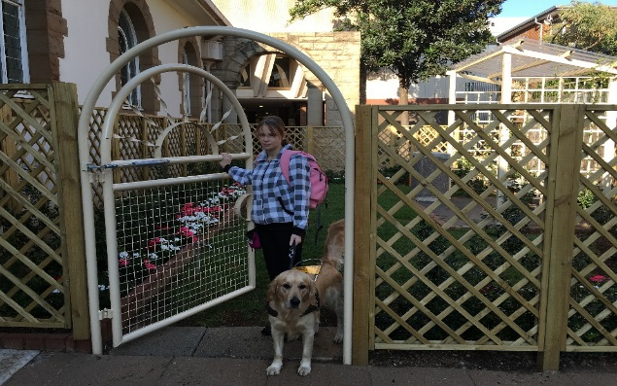
Casual Day 2016 - UP YOUR GAME
The Centre for Augmentative and Alternative Communication (CAAC) at the University of Pretoria hosted a 'mini-Olympics' in line with this year's Casual Day theme, 'Up your game' on Friday, 2 September 2016. The CAAC was joined by the third-year speech-language and audiology students from UP and KMP, and representatives from UP's Disability Unit and Tuks FM, for various fun activities to raise awareness of people with disabilities. The CAAC was also joined by three young adults with disabilities: Carla van Nieuwenhuizen, Arthur Gough and Kosie Schoeman.
UCT Boasts Deaf Class Medallist and Member of Golden Key Society
Despite being Deaf and making use primarily of South African Sign Language Jessica Bothma has been receiving impressive awards and recognition. In September she received the class medal for a Sociology course in which she scored the highest marks during the June exams of 2015. She made the Dean’s Merit List in her second year (2015); she has also recently been invited to join the Golden Key Project. Jessica is majoring in Sociology and Environmental and Geographical Sciences and should have graduated in December, but I fear this important symbolic occasion will now be postponed until sometime next year.
Already as a first year Jessica was elected on to the Humanities Student Counsel and she has been active in disability advocacy initiatives. Jessica is hoping to enrol for an honours degree in Sociology. We wish her all the best.
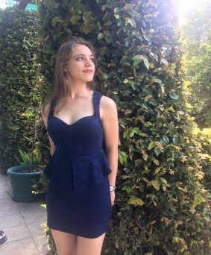

In conclusion we wish you all a safe and productive time as we look forward to the end of the year. Please continue to send news from your institutions, or raise issues you feel HEDSA need to address, debate, advocate for, etc. You can now also follow us on twitter @HEDSA_ORG.

Reinette Popplestone
Chairperson
Higher and Further Education Disability Service Association

